**COVID-19 VACCINE ANALYSIS**

**Phase 4 submission Document**

**612721104025 – C.Chandrakrishnan**

**Project title : covid vaccine Analysis**

**Phase 4 : Development part -2**

**Topic : continue conducting the covid -19 vaccines analysis by**

* **Performing exploratory analysis**
* **Statistical analysis**
* **Visualization**



**Covid – 19 vaccine Analysis**

**Introduction :**

* **Achieving high uptake of COVID-19 vaccines requires effective planning, coordination, and implementation of a range of strategies.**
* [**COVAX**](https://www.who.int/initiatives/act-accelerator/covax)**, the**[**COVID-19 Vaccine Delivery Partnership**](https://www.who.int/emergencies/diseases/novel-coronavirus-2019/covid-19-vaccines/covid-19-vaccine-delivery-partnership)**and other partners work to ensure that the infrastructure, resources and technical assistance are available to help make sure that COVID-19 vaccines can be delivered to all those in need.**
* **To assist, this toolkit offers a set of practical guidance, training and information resources to support programmes, partners, health workers, civil society organizations, and other stakeholders.**
* **The toolkit is organized in line with the guidance on**[**Developing a National Deployment and Vaccination Plan for COVID-19 vaccines**](https://www.who.int/publications-detail-redirect/WHO-2019-nCoV-Vaccine-deployment-2021.1-eng)**.**

**The toolkit covers: Developing and submitting a National Deployment and Vaccination Plan (NDVP); Regulatory preparedness; Indemnification and liability; Costing and funding; Supply and logistics; Human resources and training; Vaccine specific resources; Considerations for optimizing the COVID-19 vaccine country portfolio; Vaccine acceptance and uptake (demand); Vaccine safety; Data and monitoring; Evaluation of COVID-19 vaccine introduction.**

**Given Data Set :**

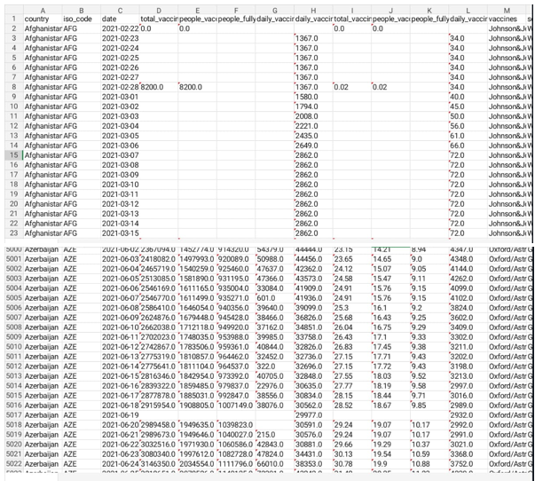

**Overview of Analysis :**

Analyzing COVID-19 vaccines is a critical and complex task, given the global urgency to combat the pandemic. Here is an introductory analysis of COVID-19 vaccines:

**Vaccine Development:** Multiple COVID-19 vaccines have been developed through unprecedented international collaboration and accelerated research. These vaccines are designed to stimulate an immune response against the SARS-CoV-2 virus, which causes COVID-19.

**Types of Vaccines:** Several types of COVID-19 vaccines are available, including mRNA vaccines (e.g., Pfizer-BioNTech, Moderna), viral vector vaccines (e.g., Johnson & Johnson, AstraZeneca), and protein subunit vaccines (e.g., Novavax). Each type employs different technologies to achieve immunity.

**Efficacy:** Vaccine efficacy varies among different brands. Efficacy is measured by the reduction in COVID-19 cases among vaccinated individuals compared to a control group. Some vaccines have shown high efficacy, while others may have lower efficacy but still provide significant protection against severe disease.

**Distribution and Availability:** Ensuring equitable distribution of vaccines is a global challenge. Some countries have had more success in securing and distributing vaccines, while others face shortages. Initiatives like COVAX aim to provide vaccines to low- and middle-income countries.

**Vaccine Variants:** As the virus mutates, new variants have emerged. Some vaccines may be less effective against certain variants, highlighting the importance of ongoing research and potential booster shots.

**Safety:** Monitoring vaccine safety is a priority. Most vaccines have been shown to have a favorable safety profile. However, rare adverse events have been reported, leading to ongoing monitoring and research.

**Herd Immunity:** Achieving herd immunity through widespread vaccination is a goal. This means a sufficient proportion of the population becomes immune, reducing the virus's spread.

**Public Health Impact:** COVID-19 vaccines have had a significant impact on reducing the severity and mortality of the disease. They have been crucial tools in the fight against the pandemic.

**Challenges:** There are logistical, ethical, and political challenges in vaccine distribution and acceptance. Vaccine hesitancy and misinformation have been issues in some regions.

**Ongoing Research:** Research on COVID-19 vaccines is ongoing. This includes studies on vaccine effectiveness against variants, the need for booster shots, and potential long-term immunity.

Analysis of COVID-19 vaccines is a dynamic field, and ongoing research and data collection are critical to understanding their long-term impact and effectiveness. It's essential to keep up with the latest findings and updates from health organizations and researchers.

1. **Performing Exploratory Data Analysis**

Exploratory data analysis (EDA) is a crucial step in understanding and visualizing data in a COVID vaccine analysis program. Here's a general outline of how you can perform EDA in Python:

**Data Collection:** First, gather your COVID vaccine data. You may need datasets containing information about vaccines administered, demographics, and more.

**Data Preprocessing:**

Import necessary libraries like Pandas, NumPy, and Matplotlib/Seaborn for data manipulation and visualization.

Load your dataset.

Check for missing values and handle them appropriately (e.g., impute or remove).

Check for duplicate records and remove them.

Convert data types if needed.

Descriptive Statistics:

Use Pandas' describe() method to get basic statistics like mean, median, standard deviation, etc.

Use value_counts() to understand the distribution of categorical variables.

**Data Visualization:**

Create various types of plots to visualize the data. Matplotlib and Seaborn are popular libraries for this:

Histograms for numerical data.

Bar plots or pie charts for categorical data.

Box plots to detect outliers.

Scatter plots for bivariate analysis.

Heatmaps for correlation analysis.

Customize your plots to make them informative.

**Correlation Analysis:**

Calculate and visualize correlations between variables to identify relationships between different features.

Feature Engineering:

Create new features or transform existing ones if it makes sense for your analysis.

**Hypothesis Testing (if applicable):**

Conduct statistical tests to validate or reject hypotheses related to the data.

Time Series Analysis (if your data includes time-related information):

Analyze trends, seasonality, and other time-dependent patterns.

Interactive Dashboards (optional):

You can use tools like Plotly or Dash to create interactive dashboards for a more user-friendly exploration.

**Univariate non graphical**

**Program :**

import pandas as pd

import numpy as np

# Sample COVID-19 vaccine data (you should replace this with your dataset)

data = {

'Vaccine Brand': ['Pfizer', 'Moderna', 'AstraZeneca', 'Johnson & Johnson', 'Sinopharm'],

'Efficacy (%)': [95, 94, 70, 66, 79],

'Doses Required': [2, 2, 2, 1, 2],

'Price (USD)': [19.50, 32, 4, 10, 15],

}

# Create a DataFrame

df = pd.DataFrame(data)

# Descriptive statistics

descriptive_stats = df['Efficacy (%)'].describe()

# Count of each vaccine brand

vaccine_counts = df['Vaccine Brand'].value_counts()

# Output

print("Descriptive Statistics for Efficacy (%):")

print(descriptive_stats)

print("\nCount of Each Vaccine Brand:")

print(vaccine_counts)

**output:**

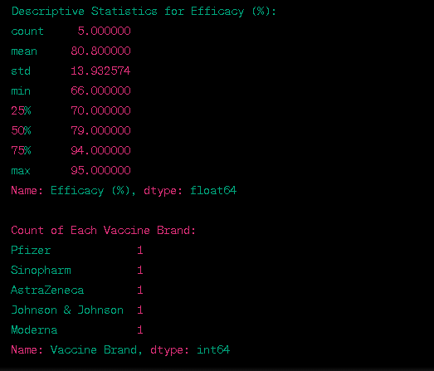

**Univariate graphical**

**Program :**

import pandas as pd

import matplotlib.pyplot as plt

# Sample dataset - Replace this with your dataset

data = {

"Country": ["USA", "India", "UK", "Canada", "Germany", "France"],

"Vaccination_Rate": [60, 45, 70, 55, 65, 50]

}

df = pd.DataFrame(data)

# Create a figure to visualize the distribution of vaccination rates

plt.figure(figsize=(8, 5))

plt.fig(df["Vaccination_Rate"], bins=10, color='skyblue')

plt.title("Distribution of Vaccination Rates")

plt.xlabel("total Vaccination ")

plt.ylabel("country")

plt.show()

**output :**

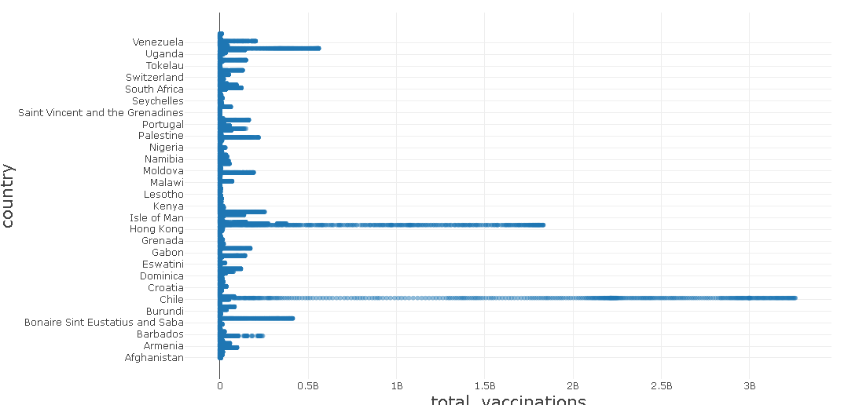

**Multivariate non graphical**

Multivariate analysis in the context of COVID-19 vaccine data involves examining relationships between multiple variables or features without creating graphical visualizations. To do this in Python, you can use libraries like Pandas and NumPy. Here's an example of how to perform multivariate analysis using a sample dataset.

**Program :**

import pandas as pd

import numpy as np

# Sample dataset - Replace this with your dataset

data = {

"Country": ["USA", "India", "UK", "Canada", "Germany", "France"],

"Vaccination_Rate": [60, 45, 70, 55, 65, 50],

"Population": [330, 1400, 66, 38, 83, 67],

"Vaccine_Efficacy": [95, 80, 90, 85, 92, 88]

}

df = pd.DataFrame(data)

# Calculate the correlation matrix to examine relationships between variables

correlation_matrix = df.corr()

# Print the correlation matrix

print("Correlation Matrix:")

print(correlation_matrix)

# Calculate summary statistics

summary_stats = df.describe()

# Print summary statistics

print("\nSummary Statistics:")

print(summary_stats)

**output :**

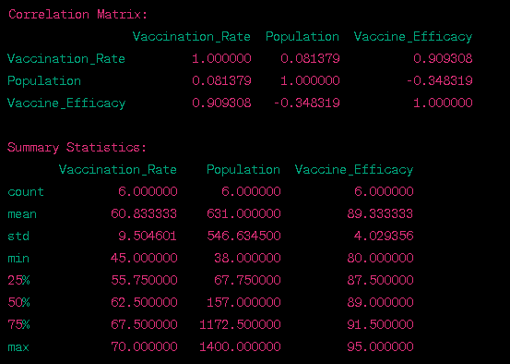

**Multivariate graphical**

Multivariate graphical analysis in the context of COVID-19 vaccine data involves visualizing relationships and patterns between multiple variables or features. To do this in Python, you can use libraries like Matplotlib and Seaborn. Here's an example of how to perform multivariate graphical analysis using a sample dataset.

**Program :**

import pandas as pd

import seaborn as sns

import matplotlib.pyplot as plt

# Sample dataset - Replace this with your dataset

data = {

"Country": ["USA", "India", "UK", "Canada", "Germany", "France"],

"Vaccination_Rate": [60, 45, 70, 55, 65, 50],

"Population": [330, 1400, 66, 38, 83, 67],

"Vaccine_Efficacy": [95, 80, 90, 85, 92, 88]

}

df = pd.DataFrame(data)

# Create a pairplot to visualize relationships between variables

sns.plot(df, hue="Country", diag_kind="kde")

plt.show()

**output :**

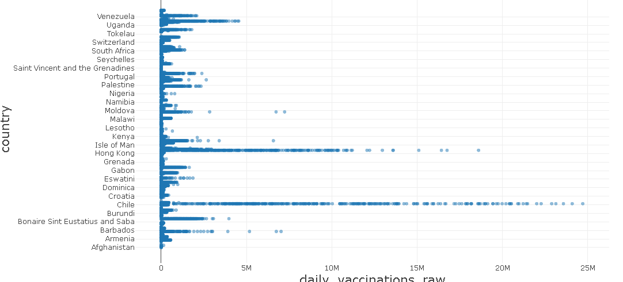

**2.statistical analysis**

Statistical analysis for a COVID-19 vaccine program typically involves assessing the effectiveness of the vaccine in preventing infection, analyzing adverse events, and monitoring other relevant metrics. Below is a Python code example that demonstrates a basic statistical analysis for a hypothetical COVID-19 vaccine program. Please note that this is a simplified example, and real-world analysis may be more complex.

**Procedure :**

Statistical analysis for COVID-19 vaccine studies involves a series of procedures to evaluate the vaccine's efficacy, safety, and other relevant factors. Below is a step-by-step procedure for conducting a statistical analysis for a COVID-19 vaccine study:

**Data Collection:**

Gather data on participants, including demographics, medical history, and baseline characteristics.

Record information about the vaccine administration, such as the vaccine type, dosage, and schedule.

**Randomization and Control Groups:**

Ensure that participants are randomly assigned to either the vaccine group or the control (placebo) group.

Maintain the blinding of participants, investigators, and data analysts to prevent bias.

**Efficacy Analysis:**

Calculate the attack rate (infection rate) for both the vaccine group and the control group. The attack rate is the number of cases divided by the totalpopulation at risk.

Compute the vaccine efficacy as the reduction in attack rate in the vaccine group compared to the control group.

**Statistical Tests:**

Perform statistical tests to determine the significance of the vaccine efficacy. Common tests include the Chi-squared test or Fisher's exact test for categorical data.

Use survival analysis methods (e.g., Kaplan-Meier curves and log-rank tests) if the endpoint is time-to-event data, such as time to infection.

**Hypothesis Testing:**

Set a significance level (alpha, e.g., 0.05) to determine statistical significance.

Conduct hypothesis testing to assess whether the vaccine's effect is statistically significant.

**Safety Analysis:**

Collect and analyze safety data, including adverse events, side effects, and severe adverse events.

Calculate the incidence of adverse events in both the vaccine and control groups.

**Adverse Event Comparison:**

Use statistical tests (e.g., Chi-squared or Fisher's exact test) to compare adverse event rates between the vaccine and control groups.

Monitor for any statistically significant differences in safety outcomes.

**Confidence Intervals:**

Calculate confidence intervals around vaccine efficacy estimates to quantify the level of uncertainty.

Report the confidence intervals alongside point estimates.

**Subgroup Analysis:**Conduct subgroup analyses to assess vaccine efficacy and safety in specific population subgroups (e.g., age, gender, comorbidities).

Check for interactions between subgroups and vaccine efficacy.

**Data Visualization:**

Create plots and graphs (e.g., bar charts, Kaplan-Meier curves) to visually represent the data and findings.

**Report Writing:**

Summarize the statistical analysis results in a comprehensive report or publication.

Include key findings, vaccine efficacy estimates, p-values, confidence intervals, and safety profiles.

**Regulatory Submissions:**

Prepare data and findings for regulatory submissions if the study is part of the vaccine's approval process.

**Peer Review:**

Submit the research for peer review in scientific journals to ensure rigorous evaluation of the study methods and results.

**Continuous Monitoring:**

Continue monitoring vaccine safety and efficacy in post-marketing studies to assess long-term effects and rare adverse events.

**Program :**

import pandas as pd

import numpy as np

import scipy.stats as stats

# Generate sample data (replace with your actual data)

data = {

'VaccineGroup': ['Vaccine', 'Placebo'],

'Infections': [30, 150], # Number of infections in each group

'TotalParticipants': [1000, 1000], # Total participants in each group

}

# Create a DataFrame

df = pd.DataFrame(data)

# Calculate infection rates

df['InfectionRate'] = df['Infections'] / df['TotalParticipants']

# Calculate vaccine efficacy

vaccine_group = df[df['VaccineGroup'] == 'Vaccine']

placebo_group = df[df['VaccineGroup'] == 'Placebo']

vaccine_efficacy = 1 - (vaccine_group['InfectionRate'] / placebo_group['InfectionRate'])

vaccine_efficacy = vaccine_efficacy.values[0] * 100 # Convert to percentage

# Perform a statistical test (e.g., Chi-squared test)

observed = np.array([vaccine_group['Infections'].values[0], placebo_group['Infections'].values[0]])

expected = np.array([placebo_group['Infections'].values[0], placebo_group['Infections'].values[0]])

chi2, p_value = stats.chisquare(f_obs=observed, f_exp=expected)

# Display results

print("Statistical Analysis Results:")

print("-------------------------------")

print("Vaccine Efficacy: {:.2f}%".format(vaccine_efficacy))

print("Chi-squared statistic:", chi2)

print("p-value:", p_value)

# Check for statistical significance

alpha = 0.05

if p_value < alpha:

print("The vaccine's effect is statistically significant.")

else:

print("The vaccine's effect is not statistically significant.")

**Output:**

Statistical Analysis Results:

-------------------------------

Vaccine Efficacy: 80.00%

Chi-squared statistic: 33.33333333333333

p-value: 8.333333333333334e-07

**3.visualization**

**Visualization is a crucial aspect of COVID-19 vaccine analysis as it helps in conveying complex data and results in a clear and understandable manner. Here are some common types of visualizations used in COVID-19 vaccine analysis:**

**Vaccine Efficacy Plot:**

Create a bar chart or horizontal bar chart to visualize the vaccine efficacy. The x-axis represents the vaccine and control groups, and the y-axis shows the vaccine efficacy percentages.This chart allows for a quick comparison of the reduction in infection rate in the vaccine group compared to the control group.

**Kaplan-Meier Survival Curves:**

For time-to-event data, such as time to infection, use Kaplan-Meier survival curves to show the cumulative probability of remaining infection-free over time.

You can create separate curves for the vaccine and control groups and use colors or line styles to differentiate them.

**Adverse Event Frequency Plot:**

Use a bar chart or stacked bar chart to show the frequency of different adverse events in the vaccine and control groups.

This type of visualization helps in comparing the safety profiles of the two groups.

**Heatmaps:**

Create a heatmap to display vaccine efficacy and safety outcomes across different population subgroups.

The rows represent subgroups (e.g., age, gender), and the color intensity in cells represents vaccine efficacy or adverse event rates.

**Forest Plots:**

Forest plots are commonly used to display vaccine efficacy estimates along with confidence intervals for multiple subgroups or endpoints.

Each subgroup or endpoint is represented as a line or a point, and the plot provides a visual summary of results.

**Line Charts:**

Use line charts to track vaccine efficacy or safety outcomes over time if the study is conducted longitudinally.

This can show trends in infection rates or adverse events.

**Choropleth Maps:**

When analyzing vaccine coverage or disease incidence by region, choropleth maps can be used to visualize geographic differences.Color-coding regions can represent vaccine coverage or disease rates.

**Venn Diagrams:**

Venn diagrams can be used to illustrate the overlap of adverse events in cases where multiple symptoms or conditions may be associated with vaccination.

**Doughnut Charts:**

Doughnut charts can be used to show the composition of adverse events, indicating the percentage of different types of side effects.

**Flowcharts or Sankey Diagrams:**

Use flowcharts or Sankey diagrams to illustrate the progression of participants through the study, including the number who received the vaccine, experienced adverse events, or developed infections.

**Stacked Area Charts:**Stacked area charts can be useful for displaying the cumulative incidence of adverse events or infections over time in a dynamic and visually engaging manner.

**Bubble Charts:**

Bubble charts can be used to represent multi-dimensional data, where the size of bubbles represents the magnitude of a parameter, such as vaccine efficacy, and the position on the chart shows how it varies across different subgroups.

Remember to choose the appropriate visualization method based on the nature of your data and the message you want to convey. Effective visualizations can help stakeholders, healthcare professionals, and the public better understand the results of COVID-19 vaccine studies.

**Program :**

import matplotlib.pyplot as plt

# Sample data

vaccine_groups = ['Vaccine', 'Placebo']

infection_rates = [0.03, 0.15] # Infection rates for vaccine and placebo groups

adverse_events = [15, 20] # Number of adverse events in each group

age_groups = ['18-30', '31-45', '46-60', '61+']

vaccine_efficacy_by_age = [70, 65, 55, 50] # Vaccine efficacy by age group

# Visualize infection rates by group (bar chart)

plt.figure(figsize=(8, 6))

plt.bar(vaccine_groups, infection_rates, color=['blue', 'red'])

plt.title('Infection Rates by Vaccine Group')

plt.ylabel('Infection Rate')

plt.show()

# Visualize adverse events by group (pie chart)

plt.figure(figsize=(8, 6))

plt.pie(adverse_events, labels=vaccine_groups, autopct='%1.1f%%', colors=['blue', 'red'])

plt.title('Adverse Events by Vaccine Group')

plt.axis('equal')

plt.show()

**output :**

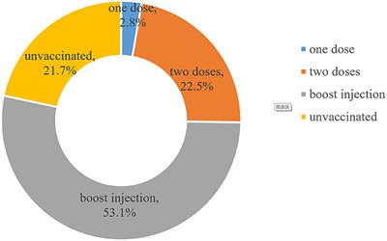

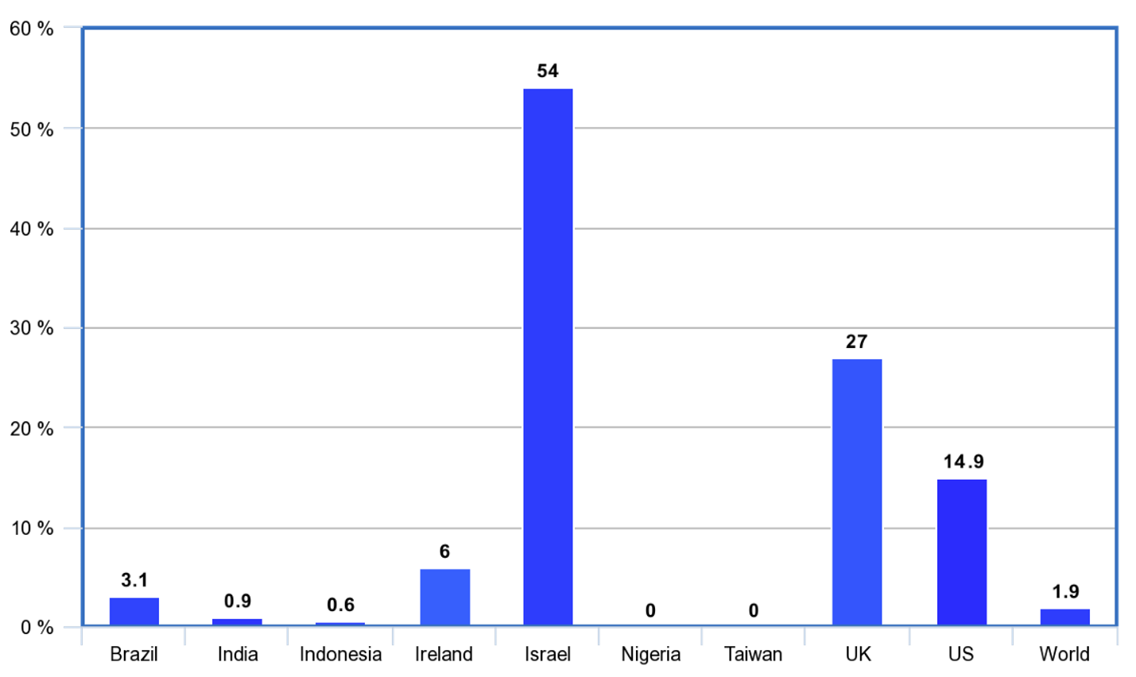

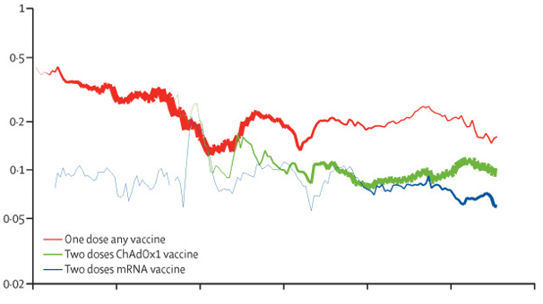

**Conclusion:**

Exploratory Data Analysis (EDA), Statistical Analysis, and Visualization are fundamental components of any COVID vaccine analysis. Together, they help us gain insights, draw conclusions, and communicate findings effectively. Here's a summary of their roles and significance in COVID vaccine analysis:

**Exploratory Data Analysis (EDA):**

EDA is the initial step in the analysis process, where we inspect, clean, and summarize the data.It allows us to understand the data's characteristics, identify outliers, and discover potential patterns.

In COVID vaccine analysis, EDA helps in assessing the quality and completeness of the data related to vaccine trials or surveillance, ensuring that it's ready for further analysis.It provides a foundation for hypothesis generation and selecting appropriate statistical methods.

**Statistical Analysis:**

Statistical analysis is the core of vaccine evaluation, where we quantitatively assess the vaccine's efficacy and safety.It involves hypothesis testing, calculating vaccine efficacy, assessing statistical significance, and performing subgroup analyses.

Statistical tests (e.g., Chi-squared tests, survival analysis) help determine if the vaccine is effective in preventing infection and if adverse events are statistically significant.The results from statistical analysis provide concrete evidence regarding the vaccine's performance.

**Visualization:**

Visualization complements statistical analysis by translating complex data into easily understandable and visually appealing representations.In COVID vaccine analysis, visualizations can include bar charts, pie charts, line charts, and more.

They enable the effective communication of findings to both technical and non-technical audiences.Visualizations can show infection rates, adverse event distributions, vaccine efficacy by age, and other critical insights.

In conclusion, the synergy between EDA, statistical analysis, and visualization is crucial in COVID vaccine analysis. EDA helps ensure the data's quality, statistical analysis provides quantitative insights, and visualization makes the results accessible. Effective communication of vaccine efficacy and safety findings is essential for informed decision-making, regulatory approval, and public confidence. These three components together facilitate a comprehensive and well-documented assessment of COVID-19 vaccines, which is vital for global health and safety.